# **Create a basic web server that serves HTML pages with socket programming**

## Step 1: Create Your HTML File

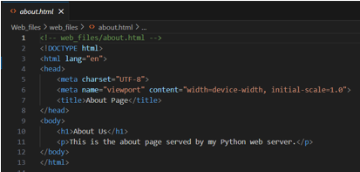

## Step 2: Modify the Server Code

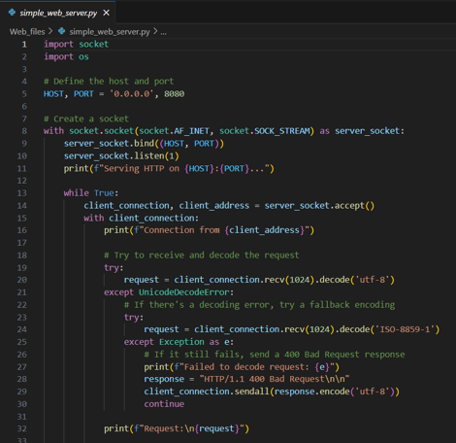

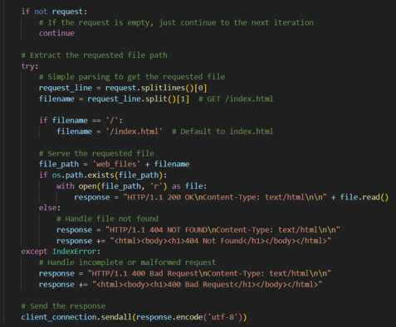

## Step 3: Run the Web Server - *python simple_web_server.py*

## Step 4: Access the Custom Web Page



